Return form to the editorial office: editorial@humanreproduction.co.uk

The enclosed manuscript,
Title: Parity is not associated with multiple measures of biological age: Evidence from NHANES 1999-2010 is being submitted for consideration in: Human Reproduction
Manuscript ID: ______________________________________________________________________________

Authors Agreement
We, the authors, verify that the submitted material has not been published and is not currently submitted for publication elsewhere. We agree (i) to the inclusion of our names as authors on the manuscript; (ii) to the order in which our names are shown on the title page of the manuscript; (iii) that all persons listed as authors fulfil the International Committee of Medical Journal Editors (ICMJE) criteria for authorship; and (iv) that no persons who fulfil the ICMJE criteria for authorship have been omitted from the author list.

Author(s) and role in the study | Signature
Talia Shirazi: contributed to the study conceptualization, data analysis, data interpretation, and manuscript writing | 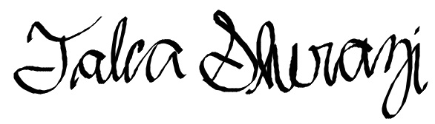
Waylon Hastings: contributed to the study conceptualization, data analysis, data interpretation, and manuscript writing | 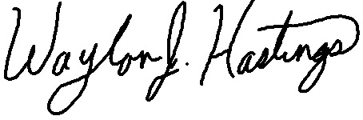
Calen Ryan: contributed to the study conceptualization, data analysis, data interpretation, and manuscript writing | 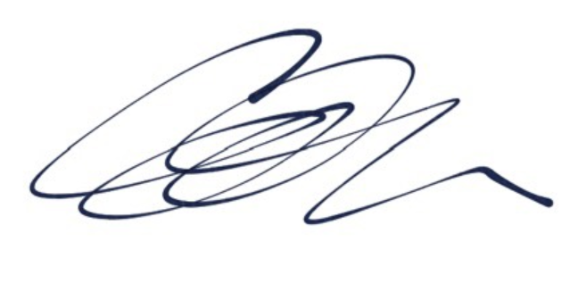
Asher Rosinger: contributed to the data analysis, data interpretation, and manuscript writing | 

Conflict of Interest
ESHRE Journals’ policy requires that all authors of all manuscripts, sign a statement revealing (1) any financial interest in or arrangement with a company whose product was used in a study or is referred to in a manuscript. This includes directorships, direct company employment, shareholding (personal or immediate family), consultancy, membership of Advisory Boards, paid lectures, research grants or any other involvement that the author can perceive that a third party may consider creates a conflict of interest; (2) any financial interest in or arrangement with a competing company; (3) any direct payment to an author(s) from any source for the purpose of writing the manuscript; and (4) any other financial connections, direct or indirect, or other situations that might raise the question of bias in the work reported or the conclusions, implications, or opinions stated – including pertinent commercial or other sources of funding for the individual author(s) or for the associated department(s) or organisation(s), personal relationships, or direct academic competition. If the manuscript is published, such information may be communicated in a note following the main text.

I confirm that I have no conflict of interest in relation to this work | I declare the existence of a conflict of interest in relation to this work and have completed an ICMJE disclosure form | Signature | Date
Talia Shirazi |  |  | 5/18/20
Waylon Hastings |  |  | 5/18/20
Calen Ryan |  |  | 5/18/20
Asher Rosinger |  |  | 5/19/20

